**What is Time Series Data Analysis**

Time Series Data Analysis is a way of studying the characteristics of the response variable with respect to time as the independent variable. To estimate the target variable in the name of predicting or forecasting, use the time variable as the point of reference. A Time-Series represents a series of time-based orders. It would be Years, Months, Weeks, Days, Horus, Minutes, and Seconds. It is an observation from the sequence of discrete time of successive intervals.

The time variable/feature is the independent variable and supports the target variable to predict the results. Time Series Analysis (TSA) is used in different fields for time-based predictions – like Weather Forecasting models, Stock market predictions, Signal processing, Engineering domain – Control Systems, and Communications Systems. Since TSA involves producing the set of information in a particular sequence, this makes it distinct from spatial and other analyses. We could predict the future using AR, MA, ARMA, and ARIMA models.

Time series forecasting is a method of predicting future events by analyzing historical data. Some examples of this include:

* Annual crop yields
* Monthly sales performances
* Cryptocurrency transactions
* 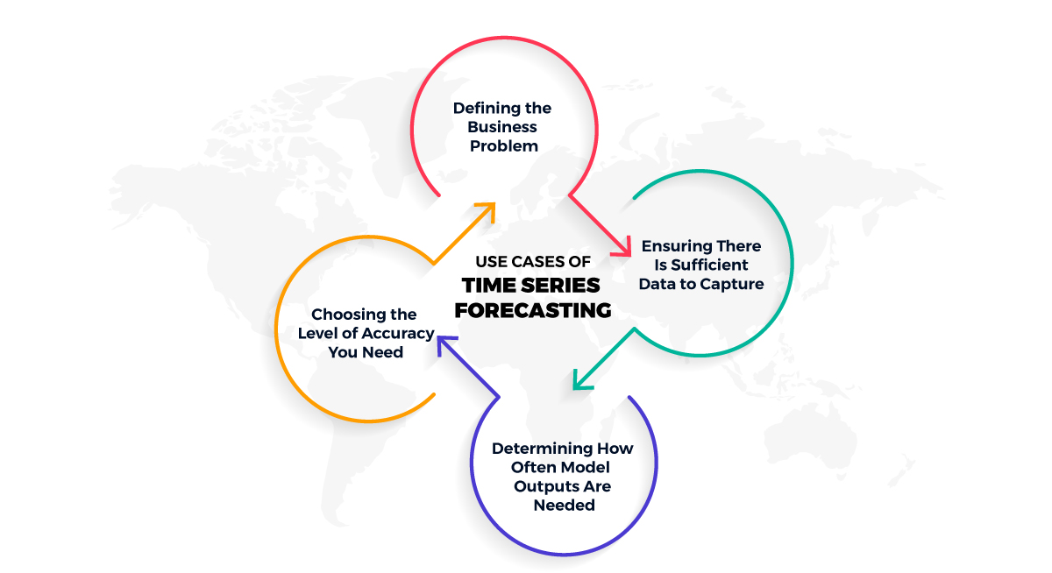

**Applications of Time Series Forecasting?**

#### **Predicting the Weather**

This is a time series forecast analysis because you can take measurements of the climate around the area you are trying to predict the weather for. Examples of variables that would be useful in performing this analysis could include

* Air temperature
* Time of day
* Wind speed
* Wind direction
* Atmospheric pressure

These data captured at a minute-by-minute or hour-by-hour cadence over years could then show you both cyclical and seasonal patterns. Random variables like earthquakes can add white noise to this time series model.

#### **Forecasting Stock Price Changes**

A common time series forecasting problem is predicting stock price changes. This method is common, although it is difficult to predict accurately, so don’t expect this to be your big break! To perform the analysis you need stock prices for a particular stock over hours, days, or months to feed into the model.

#### **Forecasting Web Traffic for an eCommerce Site**

Forecasting web interactions on a website is within the purview of time series forecasting as well. You can get much more detailed in your approach by analyzing pageview counts on specific important web pages, and clickthrough rates on important buttons.

## Time Series Models

Here are some of the most common tools used to model time series forecasting:

### Naïve, SNaïve

In time series forecasting, Naïve models assume the next data point is the same as the last. So for example, if you have daily sales data, you would predict tomorrow’s sales based on today’s. You then move one data point further down the line (the day after tomorrow) and so on. Let’s take a look at another example to make this more clear: a dataset that shows the number of passengers on flights daily. If a day had 350 passengers, the Naïve model would say that the next day would have 350 passengers.

This is helpful context for understanding the difference between the Naïve and SNaïve models. The predictions in this model are based on the last observed data point. While the Naïve model assumes that the previously seen data point is the same as the following data point, the SNaïve model introduces seasonality as a component to the analysis, which produces a closer match to the data’s trends.

This simple inclusion of seasonality as a variable in the model can improve model performance. In the below example of orders of electrical equipment by month in the European region, the difference in the two models’ performance can be seen here:

### Exponential Smoothing

The exponential smoothing forecasting method is a classic approach to the problem of forecasting data. It smoothes out the trend in your data and is calculated based on the previous data point. Say that you have weekly sales data and you want to predict the following week. A simple exponential smoothing formula that can produce a forecasted data point uses α (pronounced alpha) to denote how much smoothing you want to apply to your forecasted line. To get your forecast in this example, you would take the previous week’s actual sales data, multiply it by α, and then multiply the previous week’s forecast by 1 – α.

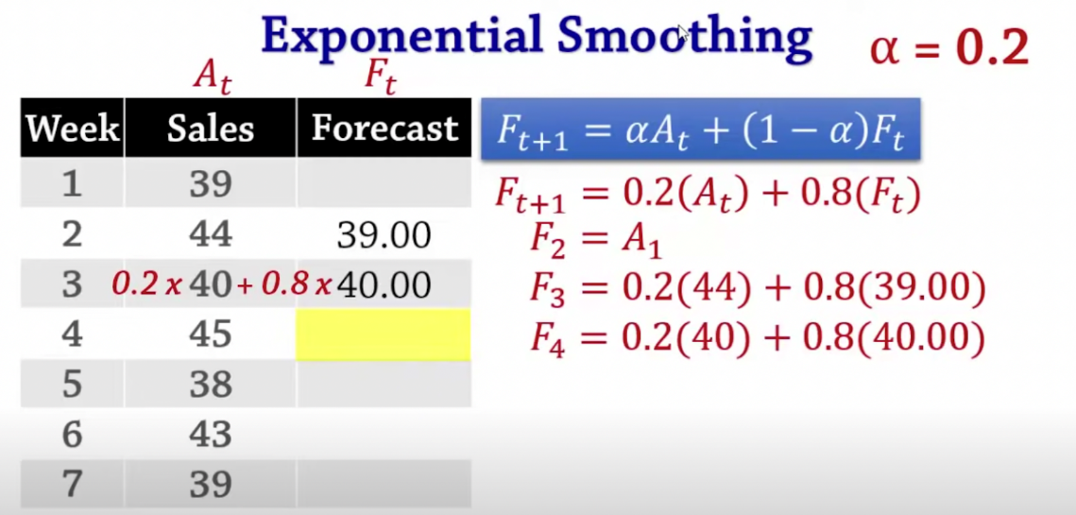

### ARIMA, SARIMA

Another commonly used model is ARIMA, which stands for AutoRegressive Integrated Moving Average. In autoregression, past observations are linearly combined to produce the forecasts. Moving Average models forecast based on a linear combination of prior errors in the forecast. Thus the ARIMA model is the integration of these two approaches. The SARIMA model is the same as the ARIMA model with the addition of seasonality.

ARIMA models need to be fit to your data and utilize a train-test split of your data to learn the patterns in the data, enabling predictions. A train-test split is when you take the majority of your data (say 70%) for the model to learn patterns from, and test it against the remaining 30% to see how well it predicts those patterns. Let’s revisit the airline passengers dataset to make this clearer. As a recap, the airline passenger dataset has counts of passengers on flights daily. The ARIMA model gets fitted to the data using that function in whatever statistical package you use in your programming language.

nce the model is fit, predictions can be made on the data and plotted to visualize the result. You can see the results of fitting an ARIMA model onto the passenger’s dataset vs. the actual data in the image below:

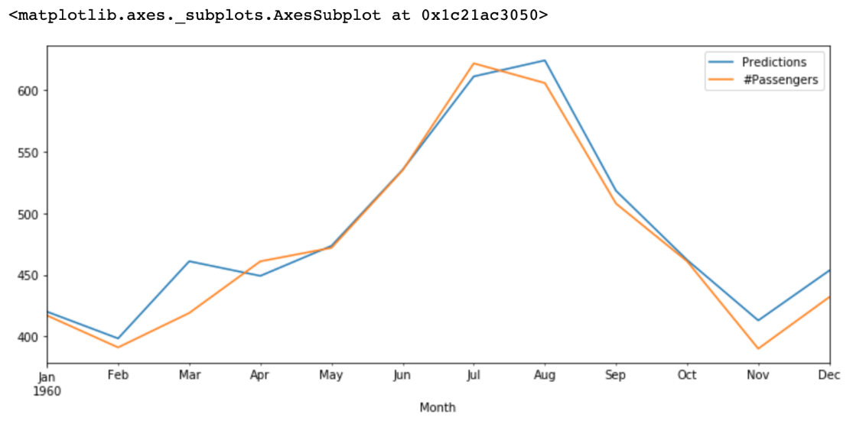

There are many factors that go into figuring out which model is best able to forecast the data you are working with. It is common to choose one or more performance measuring metrics (for example Mean Absolute Error) to evaluate the performance of multiple models. The one with the lowest total error rate based on the metric you choose can tell you which model is best suited to your dataset.

**Amazon Forecast**

Amazon Forecast, AWS’s fully managed machine learning solution, is designed to help users generate extremely precise forecasts from time-series data. Forecast forecasts future time-series data based on existing data using cutting-edge algorithms and does not require any prior machine learning knowledge. It is based on the same technology that Amazon.com uses for time-series forecasting.

**Introduction of Amazon Forecast**

Amazon has been using machine learning to solve hard forecasting problems since 2000, increasing accuracy 15X in the last two decades. It is based on the same technology as Amazon.com and can be used for a wide range of business use cases, from financial and resource planning to forecasting future performance and product demand in a variety of industries ranging from retail to healthcare.

Forecasting results can be improved, predictions can be made with greater accuracy, and business insights can be gained by automatically identifying the correlations between time-series data that change over time and independent variables such as product attributes, store locations, and so on.

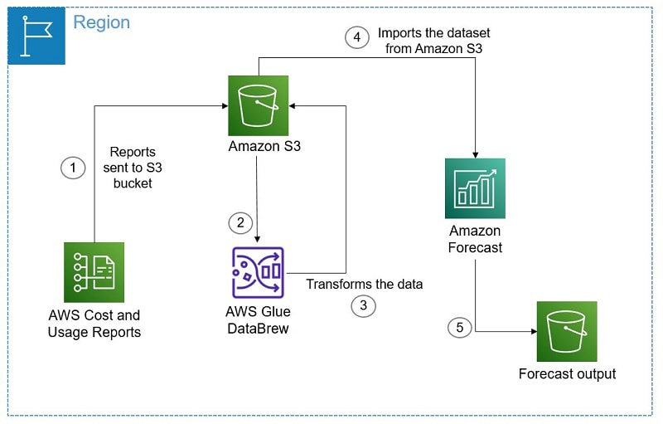

**How is Amazon Forecasting Accomplished?**

**Looking Backward**The first step is to start with historical data that has identification in the form of **timestamps, items, and values**. These provide baseline data.

***Trends Identification***  
Statistical deep-learning techniques can be used to examine historical data for trends.

***Making Predictions***  
Patterns that have been identified allowing for projected values.

## accomplishment of forecast

**What does Amazon Forecast brings to the table?**

It is a completely automated and managed machine learning service that provides extremely accurate forecasting, with an improvement of up to **50%** over conventional techniques. The service is simple to use and does not necessitate extensive training.

The mechanism underlying Amazon Forecast begins with three types of data supplied into the service from your Amazon S3 repositories: **historical data, related data, and item data.**

### outcomes of forecastWorkflow

The user is not required to manage the various background processes that Amazon Forecast employs. Examples include **data loading and inspection, training models with numerous diagrams, selecting hyperparameters for optimization, selecting the most correct model, and hosting it.**

## BTS of Amazon Forecast

**How does Amazon Forecast work?**

**Starting with Amazon Forecast**

When you create an AWS account, you go through three steps:

* ***Making and Bringing in Datasets***
* ***Choosing Predictors and algorithm***
* ***Generating Forecasts***

### ****Making and Bringing in Datasets****

**CreateDataset and DescribeDataset** are the two operations available in the Amazon Forecast tool. When creating your datasets, you specify the type of data you want to forecast as well as any other variables you want to include.

The target time-series dataset, which is required to perform time-series forecasting, includes the time series and target field for which you want to produce a forecast.

### ****Choosing Predictors and Algorithms****

Following the creation of your datasets, the Create Predictor procedure is guided by machine learning. Making a prediction requires the following:

* **Database group.**The imported data were chosen for use in the prediction training in the first step.
* **A setup for featurization.** This information is used to convert the data so that it is compatible with the training algorithm and to set the forecast frequency.
* **A prediction length or forecast horizon.**This parameter determines the range of future projections.
* **Evaluation standards.** Creating training and testing datasets from a single dataset.
* **AutoML or an algorithm.** The algorithm is used to create default values and train a model.

### ****Generating Forecasts****

The machine learning algorithm that generates forecasts considers every item in the datasets (created in the first step). The forecast frequency is set to the frequency of data collection you selected when you first created your datasets.

After you’ve generated the forecast, you can request a specific date range within it. If necessary, you can download the data as a CSV file to further filter it.

It charges **$0.6 per 1000 forecasts** generated,**$0.088 per GB** of data storage, and **$0.24 per training hour** under a pay-as-you-go pricing model.

## workflow

**Benefits of Amazon Forecast**

* It employs**machine learning** to generate more accurate demand forecasts.
* Amazon Forecast uses machine learning to learn not only the best algorithm for each item, but also the best ensemble of algorithms for each item, to automatically build the optimal model for the user’s data. This technology enables **advanced industrial robot learning**.
* The forecast includes an Explainability report in the form of affect ratings for all of the **user’s forecasts, specific time periods of interest, or selected time periods.**
* It offers developers the same technology as a fully managed service, based on Amazon.com’s **twenty years of forecasting expertise.**

## benefits of forecast

**Use cases of Amazon Forecast**

### ****One application is the addition of ML predictions to users’ SaaS products****.

The Amazon Forecast expands the capabilities of SaaS products by incorporating machine learning-based predictions to identify intricate demand correlations.

### It has a use case for better product demand forecasting.

It combines sales and demand data from the past with information about online traffic, prices, product categories, weather, and holidays.

### ****Effective resource management is one of its application cases.****

Using the Amazon Forecast, which provides precise resource need predictions in near real-time, you can increase usage and customer satisfaction.

## use cases **Pricing of Amazon Forecast**

There are **no minimum costs** or **upfront commitments** with Amazon Forecast; **you simply pay for what you use**. When using Amazon Forecast, there are four different types of charges to consider:

1. Cost per GB of data imported for training and forecasting purposes into Amazon Forecast.
2. Cost per hour of infrastructure is used for developing a unique predictor based on your input data.**Keep in mind that prices are determined by the number of instance hours consumed, not by the time required to train a predictor.**
3. Cost for several distinct forecast values that were generated over all-time series (items and dimensions) combinations.
4. The price is determined by the number of forecast data points and the number of qualities (such as price, holidays, or weather index) that are justified.

